VILNIUS UNIVERSITY FACULTY OF MATHEMATICS AND INFORMATICS DEPARTMENT OF PROGRAM SYSTEMS

**1st laboratory work**

**Point-of-sale system**

Made by:

Rosita Raišuotytė 1gr

Justas Baniulis 1gr

Eligijus Šalkauskas 4gr

Aristidas Lukas Končius 4gr

VILNIUS 2022

**Context**

1 Introduction 3

2 Roles 4

3 User story map and stories 4

3.1 Customer 5

3.1.1 Login, manage account 5

3.1.2 Create, track, and receive order 5

3.1.3 Follow/use loyalty points 7

3.1.4 Follow the news 7

3.1.5 Review history 8

3.1.6 Reserve/manage place/product/service 9

3.2 Employee 10

3.2.1 Login 11

3.2.2 Manage orders 11

3.2.3 Manage work shifts 14

3.2.4 Work in shift 14

3.3 Courier 15

3.3.1 Log in and interact with orders 16

3.4 System administrator 16

3.4.1 Log in and manage business places 17

3.5 Business administrator 17

3.5.1 Log in 18

3.5.2 Manage accounts 18

3.5.3 Manage business place 19

3.6 Business manager 20

3.6.1 Log in 21

3.6.2 Manage shifts 21

3.6.3 Manage services/products 22

3.6.4 Manage loyalty programs 23

3.6.5 Manage discounts 24

4 Data model 25

# Introduction

The purpose of this system is to apply to any kind of point-of-sale enterprise. It can be restaurants, small catering establishments, cafes, bars, vet clinics, etc. The main point of this system is that people who want to order some service or product can use our app, where can see all enterprises, which use our system, and order products/services online. There is some functionality such as making a reservation, but this can be used optionally. Also, business place must not necessarily have a delivery option, service/product can be delivered at site. Same goes for payments.

# Roles

**Customer** - people who want to go to business place and use their service. They can make online reservations, order products, accumulate loyalty points, and get discounts.

**Employee** – people (staff of business), who receive the order, make it (or pass it to other workers), and pass the order to next actor (courier or client). Employees update order‘s status, so customer can observe whether the business received it, is in making process or passed on to courier/ ready to take. Also, they see their work shift, check-in, when shift starts, and check-out, when shift ends, and report situations, when employee is not able to work (like when she/he is sick).

**Courier** – people who are responsible for delivering food from point A to point B. It is important for them to find new order quickly and see necessary information. Of course, they are responsible for the status of the order.

**System administrator** – people, who help businesses set-up their operations on our POS, like creating their instances in system, managing businesses admins accounts (this actor is our staff).

**Business administrator** – people (higher-up staff of business), who manage accounts of customers, employees, couriers, business manager (people who are responsible for one place in the business network) and business places itself (like a departments or shops).

**Business manager** - leads and supervises the work of his employees in local level (in his/her own shop/café/department). The business manager is in charge of designing business strategies and managing all day-to-day operations to guarantee company’s efficiency in his/her area. It includes activities such as shift management, loyalty programs and discounts.

# User story map and stories

## Customer

### Login, manage account

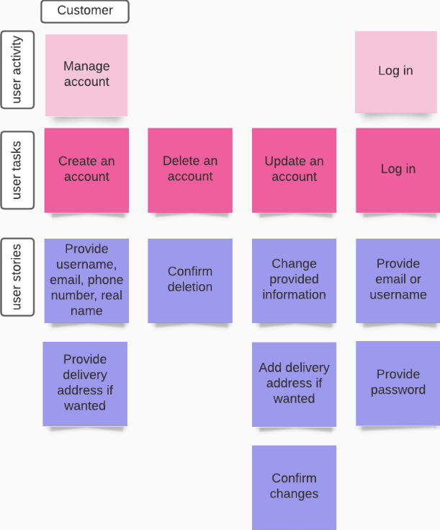

Like everywhere customer must create account and login if they want to get some extra functionality. In our system that functionality would be loyalty points, discounts, or just ability to have history of orders and quickly enter delivery address.

* As a customer I want to provide my credentials, so I can register an account when I am accessing the system for the first time. (Must implement)
* As a customer I want to provide delivery address, so I could quickly enter delivery information when I make order. (Must implement)
* As a customer I want to get popup window about confirmation so I couldn’t delete account accidentally. (Must implement)
* As a customer I want to update my account, so I could have my information correct. (Must implement)
* As a customer I want to enter my login information, so I could see my account information and track my orders. (Must implement)

### Create, track, and receive order

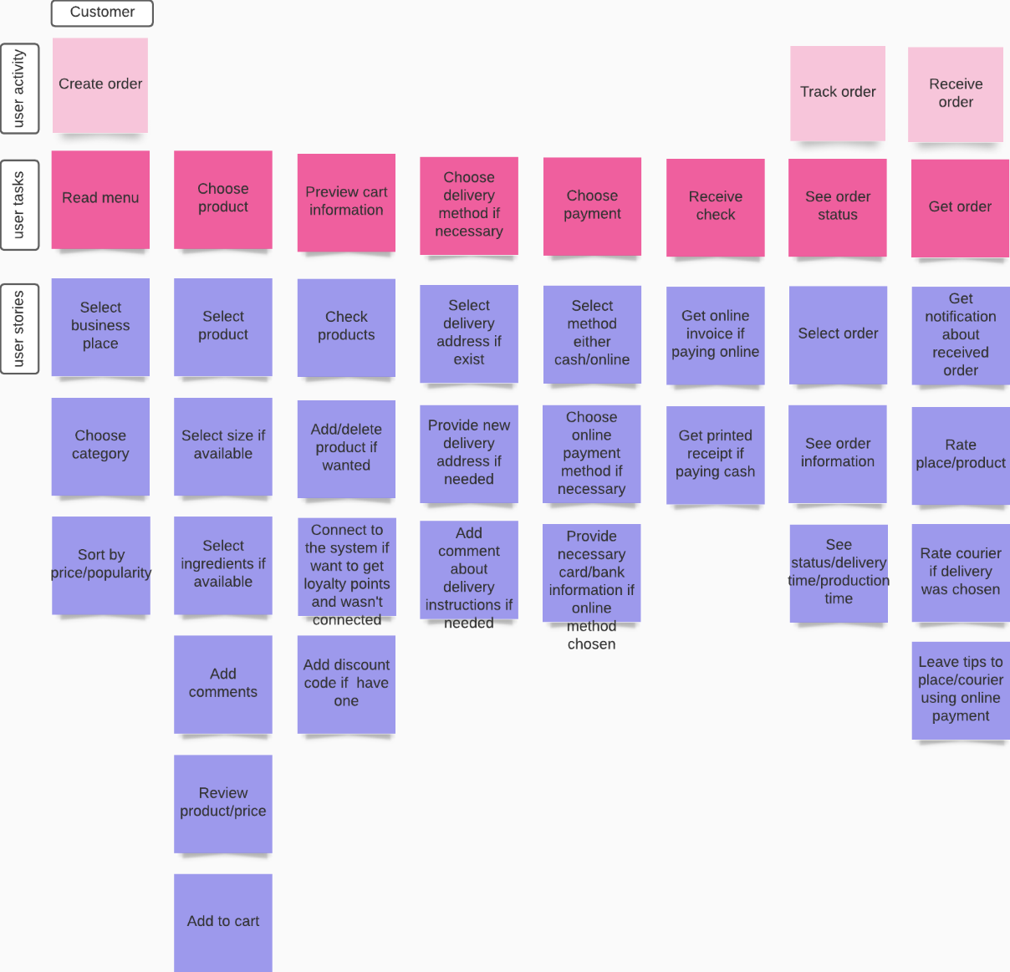

* As a customer I want to read menu in selected business place, so I could choose the product I like the most. (Must implement)
* As a customer I want to sort menu, so I could have possibility to search. (Should implement)
* As a customer I want to choose ingredients, so I could avoid allergies. (Should implement)
* As a customer I want to place an order, so I could receive the meal I order. (Must implement)
* As a customer I want to have a possibility to review order, so I could have a possibility to change products. (Must implement)
* As a customer I want to select payment type, so I could have different possibilities to pay for the meal. (Must implement)
* As a customer I want to select delivery method, so I could have a possibility to take away products. (Must implement)
* As a customer I want to choose the time to pay, so I could pay after delivery. (Must implement)
* As a customer I want to see order status, so I could track the delivery time. (Must implement)
* As a customer I want to get receipt, so I could have a proof of payment. (Must implement)
* As a customer I want to get notification about finished order, so I could have a possibility to rate the service. (Should implement)

### Follow/use loyalty points

* As a customer I want to track my loyalty points, so I could change them to the discount. (Should implement)
* As a customer I want to use loyalty card, so I could have a discount. (Should implement)

### Follow the news

* As a customer I want to get notifications in the system, so I would be informed about the news. (Could implement)
* As a customer I want to get personalize notifications, so I could use loyalty discounts for my orders. (Could implement)

### Review history

* As a customer I want to review my history, so I could see orders with my chosen products. (Could implement)

### Reserve/manage place/product/service

* As a customer I want to book service, so I could be sure I will have this on my wanted time. (Should implement)
* As a customer I want to choose reminder, so I could have notification before my booked service. (Could implement)
* As a customer I want to change my reservation date, so I could accommodate to my schedule. (Should implement)
* As a customer I want to cancel my reservation, so I could free up my reservation time for other users to use. (Should implement)

## Employee

### Login

Since employees‘ account are created by business administrators, they only need to login to access system‘s functionality, like managing orders, shifts, work.

* As an employee, I want to provide an email/username and password, so I can log into my account and have ability to use some functionality. (Must implement)

### Manage orders

Point of sale from employee‘s perspective.

* As an employee, I want to select and see archived order information, so I could check for any anomalies. (Should implement)
* As an employee, I want to search by date/customer archived orders, so I could select order more efficiently. (Could implement)
* As an employee, I want to select and see received orders information, so I could make sure what services I will provide. (Must implement)
* As an employee, I want to sort/filter orders by various criteria, so I could search for orders more efficiently. (Should implement, since they are going to be searched in faster-pace environment)
* As an employee, I want to be notified that order is received from Customer, so I could act in time. (Should implement)
* As an employee, I want to be notified that order is received from Customer, so I could act in time. (Should implement)
* As an employee, I want to be accept/decline, so I could start doing service. (Must implement)
* As an employee, I want to be provide reason if declined, so I could inform customer and make business more transparent. (Should implement)
* As an employee, I want to provide how long order will take to make, so Customer/Courier would know when he/she receives it. (Must implement)
* As an employee, I want to update status, when order/service is made, given to client or courier, when order takes more time to make than expected, so I could keep other involved actors in the known. (Must implement)
* As an employee, I want to take cash or provide card reader for customer, so I could help customer pay for oder. (Should implement)
* As an employee, I want to report courier not arriving, so I could help customer be in the known. (Must implement)
* As an employee, I want to be notified before reservation time, so I could get ready and work fluently. (Should implement)
* As an employee, I want to update status, when customer check-in for order/service, customer leaves, customer doesn‘t arrive, so business could operate fluently. (Must implement)
* As an employee, I want to be report innapproporate behaviour at the table, so business environment would feel safer. (Could implement)
* As an employee, I want to be notified that reservation is cancelled, so I wouldn‘t waste resources. (Could implement)
* As an employee, I want to create order for customer, so I could do services for him/her. (Must implement)
* As an employee, I want to update created order‘s status, when I‘m giving order to customer or customer doesn‘t take it, or customer doesn‘t pay for it, so my manager would know current situation. (Should implement)
* As an employee, I want to take money (cash or card) for created order, so order would be paid. (Must implement)

### Manage work shifts

This activity helps employee to find out what and when he/she will work.

* As an employee, I want to select shifts view by hours/weeks/months/location, so I could find my shift faster. (Could implement)
* As an employee, I want to select and see shift information, so I would know shift‘s information. (Should implement)
* As an employee, I want to select and see shift information, so I would know shift‘s information. (Could implement)

### Work in shift

* As an employee, I want to select non-work period‘s timespan, so my manager would know when I will be absent. (Could implement)
* As an employee, I want to provide reason or documents, so my manager would know why I will be absent. (Could implement)
* As an employee, I want to check-in, so my manager would know that I started working. (Must implement)
* As an employee, I want to get notified before my shift, so I wouldn‘t be late to work. (Could implement)
* As an employee, I want to check-out, so my manager would know that I stopped working. (Must implement)
* As an employee, I want to get notified before my shift end, so I wouldn‘t overwork and „wrap-up“ last clients. (Could implement)
* As an employee, I want to check-out, when personal emergency happens, so my manager would know why I stopped working out of the sudden. (Must implement)

## Courier

### Log in and interact with orders

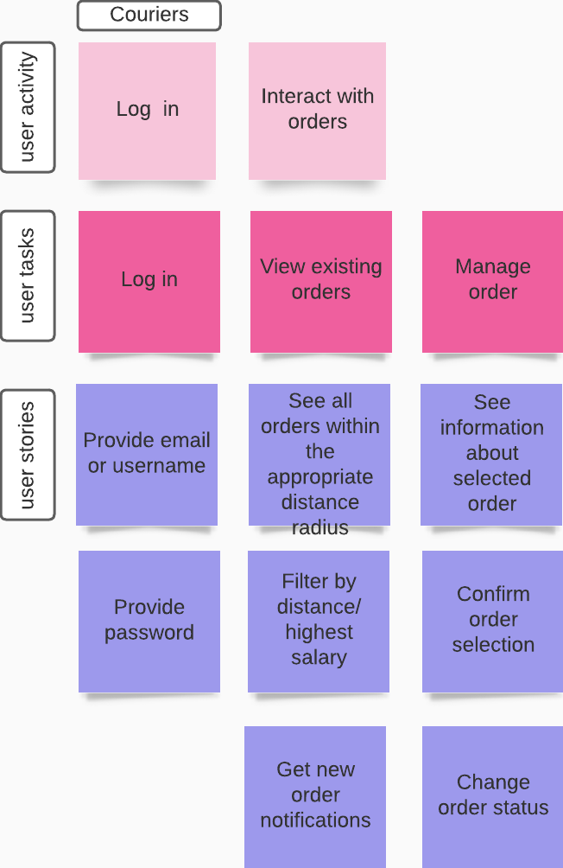

* As a courier, I want to provide an email/username and password (account are created by business administrator), so I can log into my account and have ability to use some functionality. (Must implement)
* As a courier, when looking at all orders within the appropriate distance radius, I want to be able to filter them by distance and highest salary, so that I can spend less time looking for appropriate offers. (Could implement)
* As a courier, I want to receive notifications about new orders, so I can get information about the latest orders immediately. (Could implement)
* As a courier, I want to be able to manage an order, so I can see its status, supplier & delivery location, payment method, possible salary and confirm order selection. (Should implement)
* As a courier, I want to be able to change the order’s status, so the user and business place can be up-to-date with the information concerning the order. (Must implement)

## System administrator

### Log in and manage business places

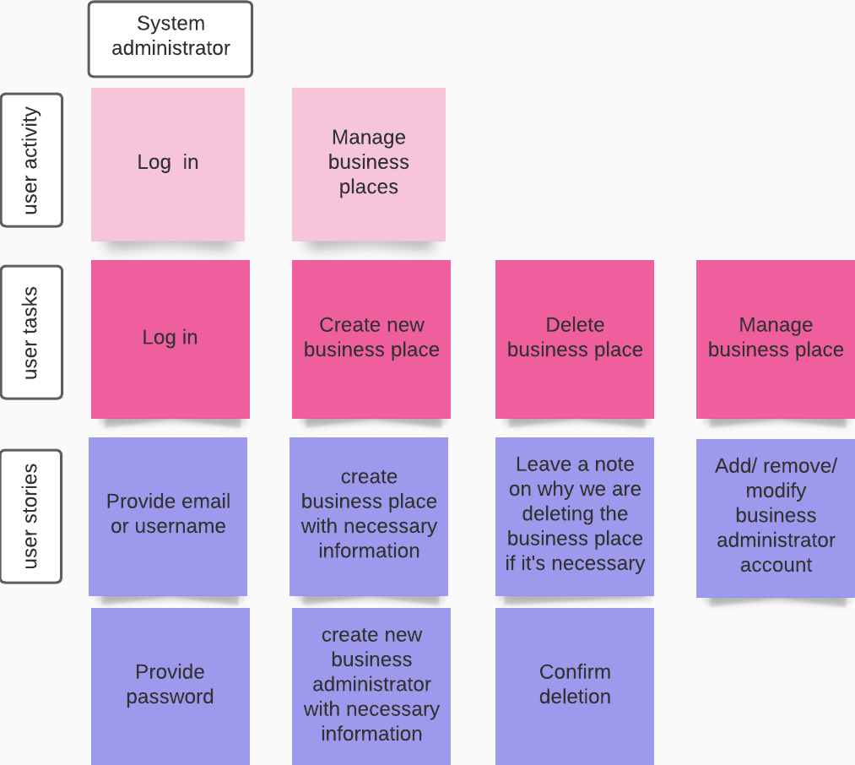

* As a system administrator, I want to provide an email/username and password (account are created by system creator team), so I can log into my account and have ability to use some functionality. (Must implement)
* As a system administrator, I want to create business place with necessary information as name, phone number, main business place address, owner information), so I can be sure that the new business place is created and the business can start running in our system. (Must implement)
* As a system administrator, I want to create business administrator with necessary information as name, phone number, email, city)/remove/modify, so I can ensure the business place list of business administrators is up to date and new/existing business administrators would be provided with accounts in good order and old ones would be deleted. (Must implement)
* As a system administrator, I want to delete business place (Must implement) and leave a note (Could implement), so I can be sure that the businesses that no longer work with our sistem are deleted and a note is left with the leaving reasons in case there are any questions or problems in the future.

## Business administrator

### Log in

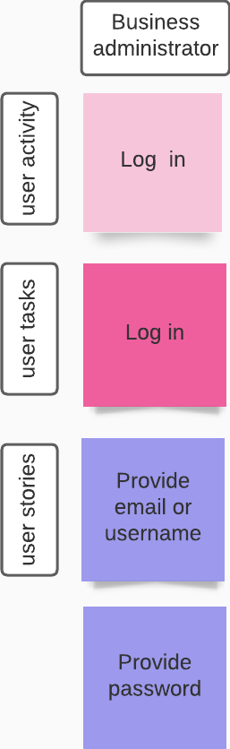

* As a business administrator, I want to provide an email/username and password (account are created by system administrator), so I can log into my account and have ability to use some functionality. (Must implement)

### Manage accounts

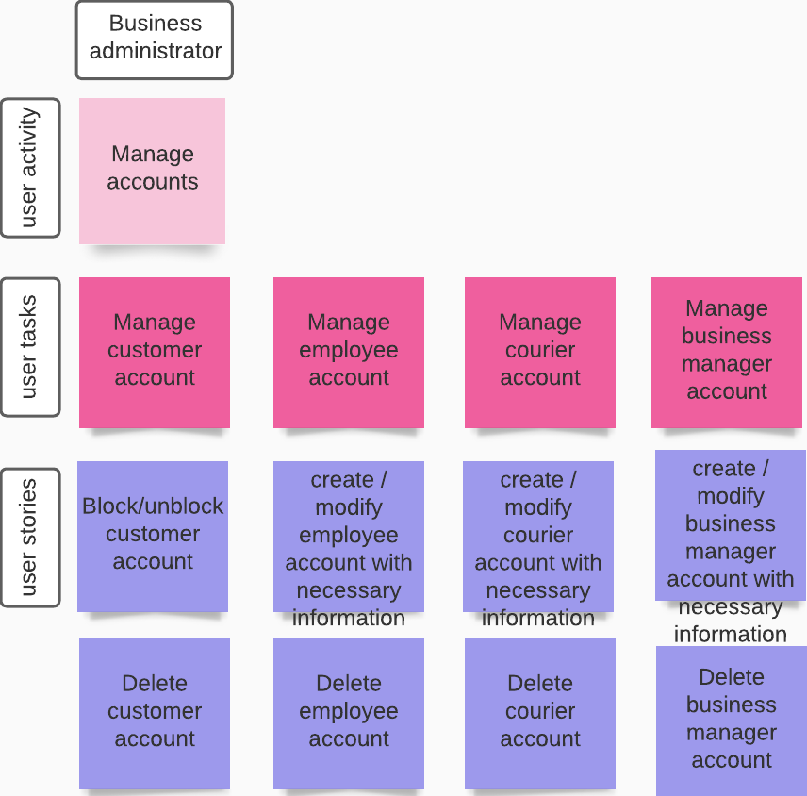

* As a business administrator, I want to be able to block/unblock and delete customer account, so that users of the system would be protected from malicious customers and I can ensure the quality of the business place experience. (Must implement)
* As a business administrator, I want to add ( with necessary information as name, salary, duties, phone number, city, email )/delete and modify employee acount, so I can ensure the business place list of employees is up to date and new/existing employees would be provided with accounts in good order and old ones would be deleted. (Must implement)
* As a business administrator, I want to add ( with necessary information as name, city, phone number, email and etc.) /delete and modify courier acount, so I can ensure the business place list of couriers is up to date and new/existing couriers would be provided with accounts in good order and old ones would be deleted. (Must implement)
* As a business administrator, I want to add ( with necessary information as name, city, phone number, email and etc.) /delete and modify business manager acount, so I can ensure the business place list of business manager is up to date and new/existing business manager would be provided with accounts in good order and old ones would be deleted. (Must implement)

### Manage business place

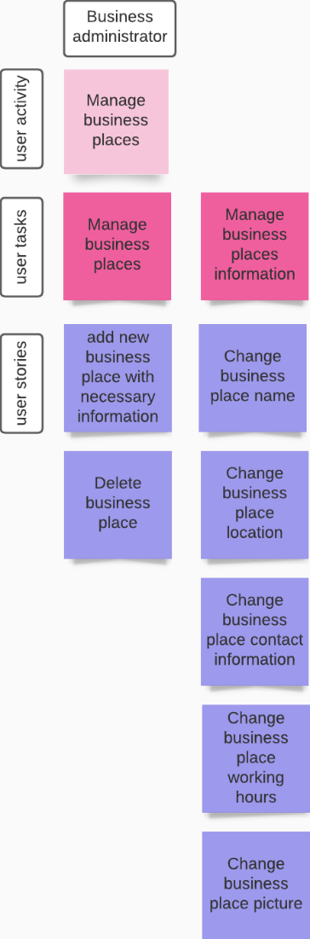

* As a business administrator, I want to add business place with necessary information as business place name, location and etc., so that users of the system will be access certain business place. (Must implement)
* As a business administrator, I want to delete business place, so that users of the system stop being able to access certain business place. (Must implement)
* As a business administrator, I want to manage business place information as name, location, contact information, place working hours, picture, so that users of the system will get the correct information about business place and thus may avoid misunderstandings. (Could implement)

## Business manager

### Log in

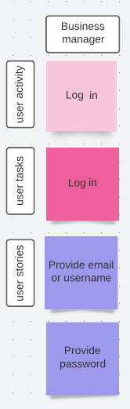

* As a business manager, I want to provide an email/username and password (account are created by business administrator), so I can log into my account and have ability to use some functionality. (Must implement)

### Manage shifts

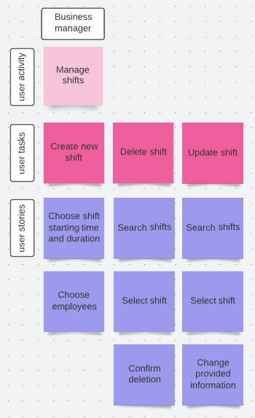

* As a business manager, I want to create shifts, so that employees know when to work and business can be more efficient and flexible. (Must implement)
* As a business manager, I want to delete shifts, so that irrelevant shifts don’t mix with relevant ones. (Must implement)
* As a business manager, I want to update shifts and change provided information (shift starting time, shift duration and employees), so that shifts can be flexible and editable. (Must implement)
* As a business manager, I want to search for shifts by name/time/employee, so that I can manage shifts faster. (Must implement)

### Manage services/products

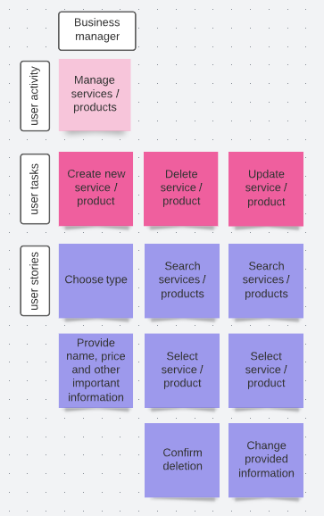

* As a business manager, I want to create services/products and provide important information (such as name, price, description), so that customers can buy our services/products. (Must implement)
* As a business manager, I want to delete services/products, so that irrelevant services/products don’t mix with relevant ones. (Must implement)
* As a business manager, I want to update services/products and change provided information (name, price, description), so that services/products can be flexible and editable. (Must implement)
* As a business manager, I want to search for services/products by name/price, so that I can manage services/products faster. (Must implement)

### Manage loyalty programs

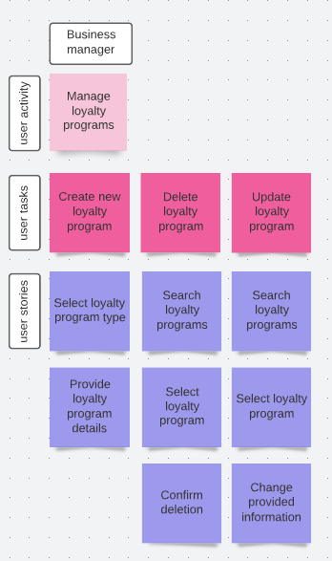

* As a business manager, I want to create loyalty program by choosing type (for example points program or cash back program) and providing important information (such as loyalty program strategy, prizes), so that clients would buy more from us and come back more often. (Must implement)
* As a business manager, I want to delete loyalty programs, so that irrelevant loyalty programs don’t mix with relevant ones. (Could implement)
* As a business manager, I want to update loyalty programs and change provided information (for example type, strategy, prizes), so that loyalty programs can be flexible and editable. (Could implement)
* As a business manager, I want to search for loyalty programs by name/type/date, so that I can manage loyalty programs faster. (Could implement)

### Manage discounts

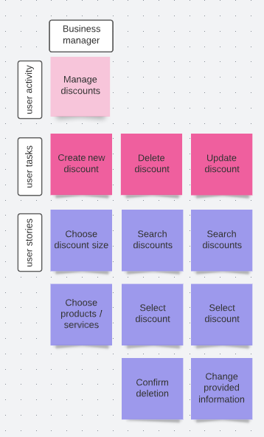

* As a business manager, I want to create discounts by providing discount size and products/services, so that it would attract new customers, build their awareness and interest in business. (Could implement)
* As a business manager, I want to delete discounts, so that old discounts would not be available. (Could implement)
* As a business manager, I want to update discounts and change provided information (for example discount size and chosen products/services), so that discounts can be flexible and editable. (Could implement)
* As a business manager, I want to search for discounts by name/percent/products/services, so that I can manage discounts faster. (Could implement)

# Data model

Clearer version (Press + in the upper right corner): <https://www.figma.com/file/R4yOcQSJ9v7WMlEwD4cyLn/UML-Diagrams-(Community)?node-id=0%3A1>